Multiple-choice section – choose the correct answer

Question 1 [2.6] [10A]

A sample of test scores from classes 10A and 10B are shown below. The differences between the means and the interquartile ranges, respectively, from the data sets are:

10A: 60, 75, 90, 72, 86, 65, 88, 83, 67, 50

10B: 66, 58, 72, 80, 60, 97, 58, 80, 50, 52

A 6.3, 0 B 6.3, 1 C 3.6, 0 D 3.6, 1

Question 2 [2.3]

The following graph shows the temperature as recorded every hour for a number of hours from noon.

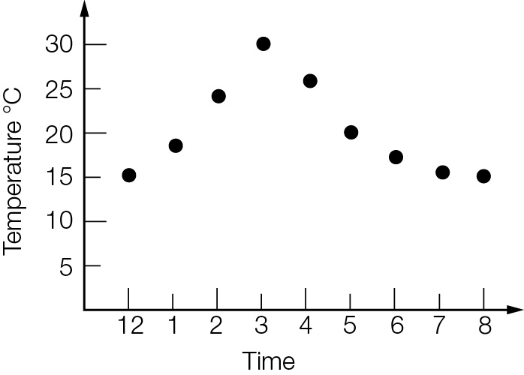

Which of the following statements is *incorrect*?

A The minimum temperature recorded was 15 °C.

B The minimum temperature reached on the day was 15 °C.

C The maximum temperature recorded on the day was 30 °C.

D The temperature rose quicker in the early afternoon than it fell in the late afternoon/evening.

Question 3 [2.5]

Which box plot represents the following data set?

1, 2, 2, 2, 3, 4, 5, 6, 6

|  |  |
| --- | --- |
| A  PM10_PR_TSa_7_02 | B  PM10_PR_TSa_7_03 |
| C  PM10_PR_TSa_7_04 | D  PM10_PR_TSa_7_05 |

Question 4 [2.4]

The relationship betweenandfor the scatter graph shown below can be best described as:

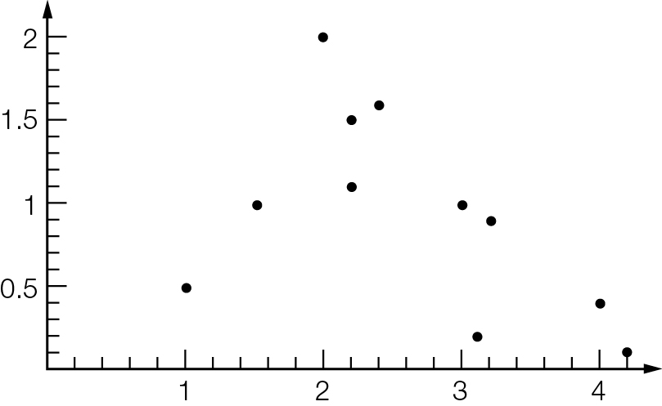

**A** perfect negative linear relationship

**B** strong negative linear relationship

**C** no linear relationship

**D** weak positive linear relationship

Question 5 [2.2]

If a data set has a lower quartile value of 16 and upper quartile of 24, then:

A a value of 6 would be considered an outlier

B values of 6 and 36 are both outliers

C neither 6 nor 36 would be outliers

D a value of 36 would be an outlier

Question 6 [2.2]

For the data set represented in the cumulative frequency graph, 60% of the data lies below what approximate value?

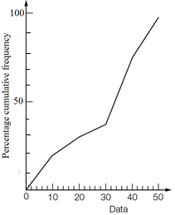

A 60 B 54 C 40 D 36

Question 7 [2.2]

The interquartile range of the data set is:

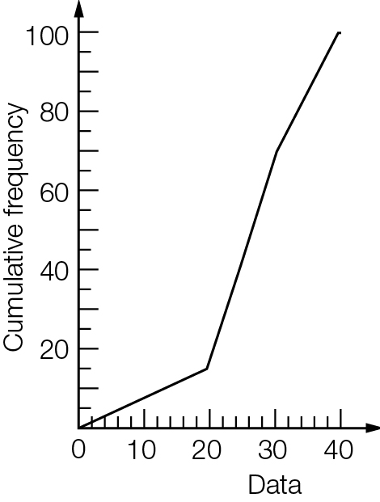

A 10 B 22 C 27 D 32

Question 8 [2.2]

The five-number summary (minimum value, lower quartile, median, upper quartile, maximum value) of a particular data set is shown below.  
 19, 23, 42, 51, 68  
Which of the following statements about the data is *untrue*?

**A** the data set contains no outliers

**B** about 25% of the values lie below 51

**C** the interquartile range is 28

**D** about 50% of the values lie below 42

Question 9 [2.8] [10A]

The mean and standard deviation, respectively, for the following data, appropriately rounded is:

4.2, 9.5, 6.3, 2.4, 0.7

**A** 4.6, 3.43 **B** 4.7, 3.07 **C** 4.7, 3.40 **D** 4.6, 3.07

Multiple-choice results: \_\_\_ / 9

Short answer section

Question 10 3 marks [2.1–2.7]

Choose from the following words and expressions to complete the sentences below.

*bivariate dependent independent mean primary secondary univariate*

**(a)** \_\_\_\_\_\_\_\_\_\_\_\_\_\_\_ data is described using two variables.

**(b)** \_\_\_\_\_\_\_\_\_\_\_\_\_ data is data collected by yourself and \_\_\_\_\_\_\_\_\_\_\_\_\_\_ data is data collected by someone else.

Question 11 5 marks [2.1]

(a) Write a set of whole number data with at least 10 values that has a lowest value of 4, a highest value of 26, lower quartile of 10, upper quartile of 18 and median of 14.

(b) Calculate the mean of your set of data correct to 1 decimal place.

Question 12 7 marks [2.1]

|  |  |
| --- | --- |
| *x* | *f* |
| 56 | 3 |
| 57 | 2 |
| 58 | 12 |
| 59 | 20 |
| 60 | 15 |

(a) Calculate the mean of the data correct to 1 decimal place.

(b) Calculate the median and quartiles of the data. Write the five-number summary.

Question 13 3 marks [2.2]

Construct a box plot from the cumulative frequency curve of 24 data. Use the horizontal axis as the axis for the box plot.

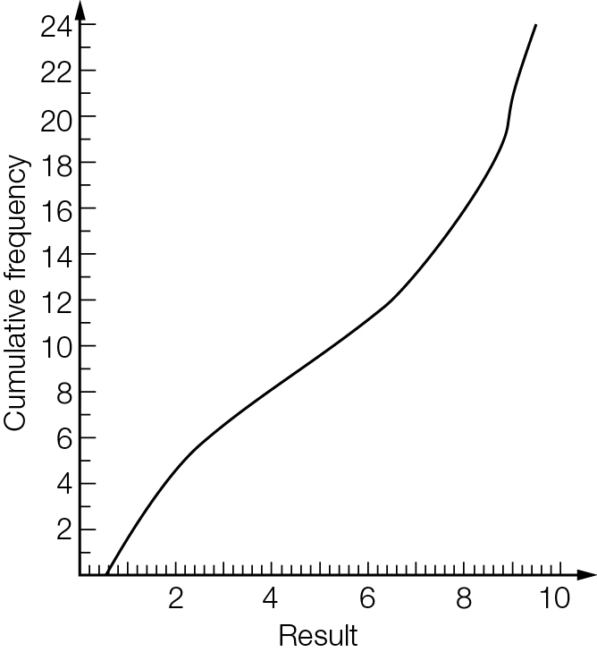

Question 14 5 marks [2.3]

(a) For each data set find the (i) median (ii) range and (iii) interquartile range.

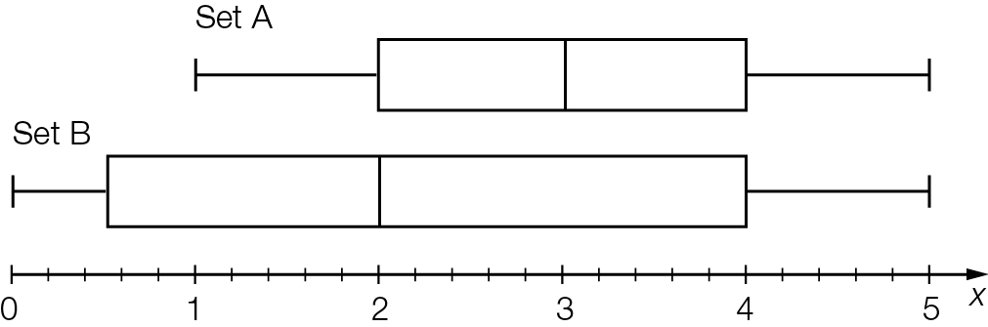

(b) Compare the statistics for the two data sets.

Question 15 3 marks [2.5]

The share price for a volatile stock was recorded each hour for a 5 hour period.

|  |  |  |  |  |  |  |
| --- | --- | --- | --- | --- | --- | --- |
| Time | 1 pm | 2 pm | 3 pm | 4 pm | 5 pm | 6 pm |
| Price | $1.20 | $2.40 | $2.50 | $1.10 | $1 | $1.30 |

(a) Draw a scatter plot of the price of the stock on the graph below.

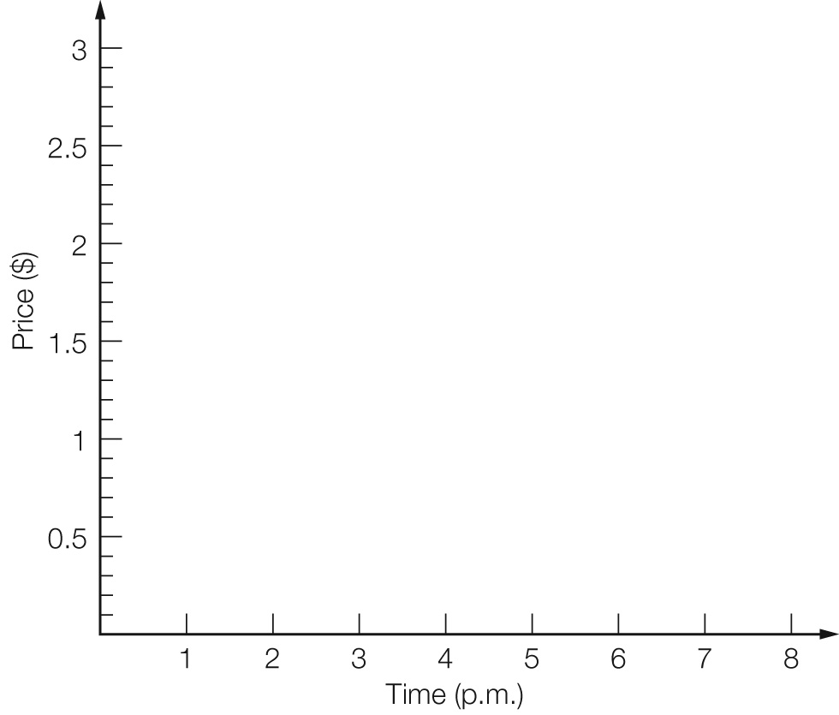

(b) Describe the price movement of the stock over the 5 hour time period.

Question 16 10 marks [2.2]

The following data are the years of death of 26 people buried in a section of a cemetery.

1955, 1944, 1934, 1908, 1955, 1866, 1934, 1945, 1945, 1961, 1944, 1947, 1956,  
1866, 1866, 1954, 1954, 1974, 1942, 1938, 1931, 1950, 1963, 1968, 1953, 1963

(a) Find the mean and median of the data. Write the mean in whole years.

(b) Identify the outliers in the list.

(c) Draw a box plot of the data.

(d) Between which years did the middle 50% of deaths occur?

Question 17 5 marks [2.7]

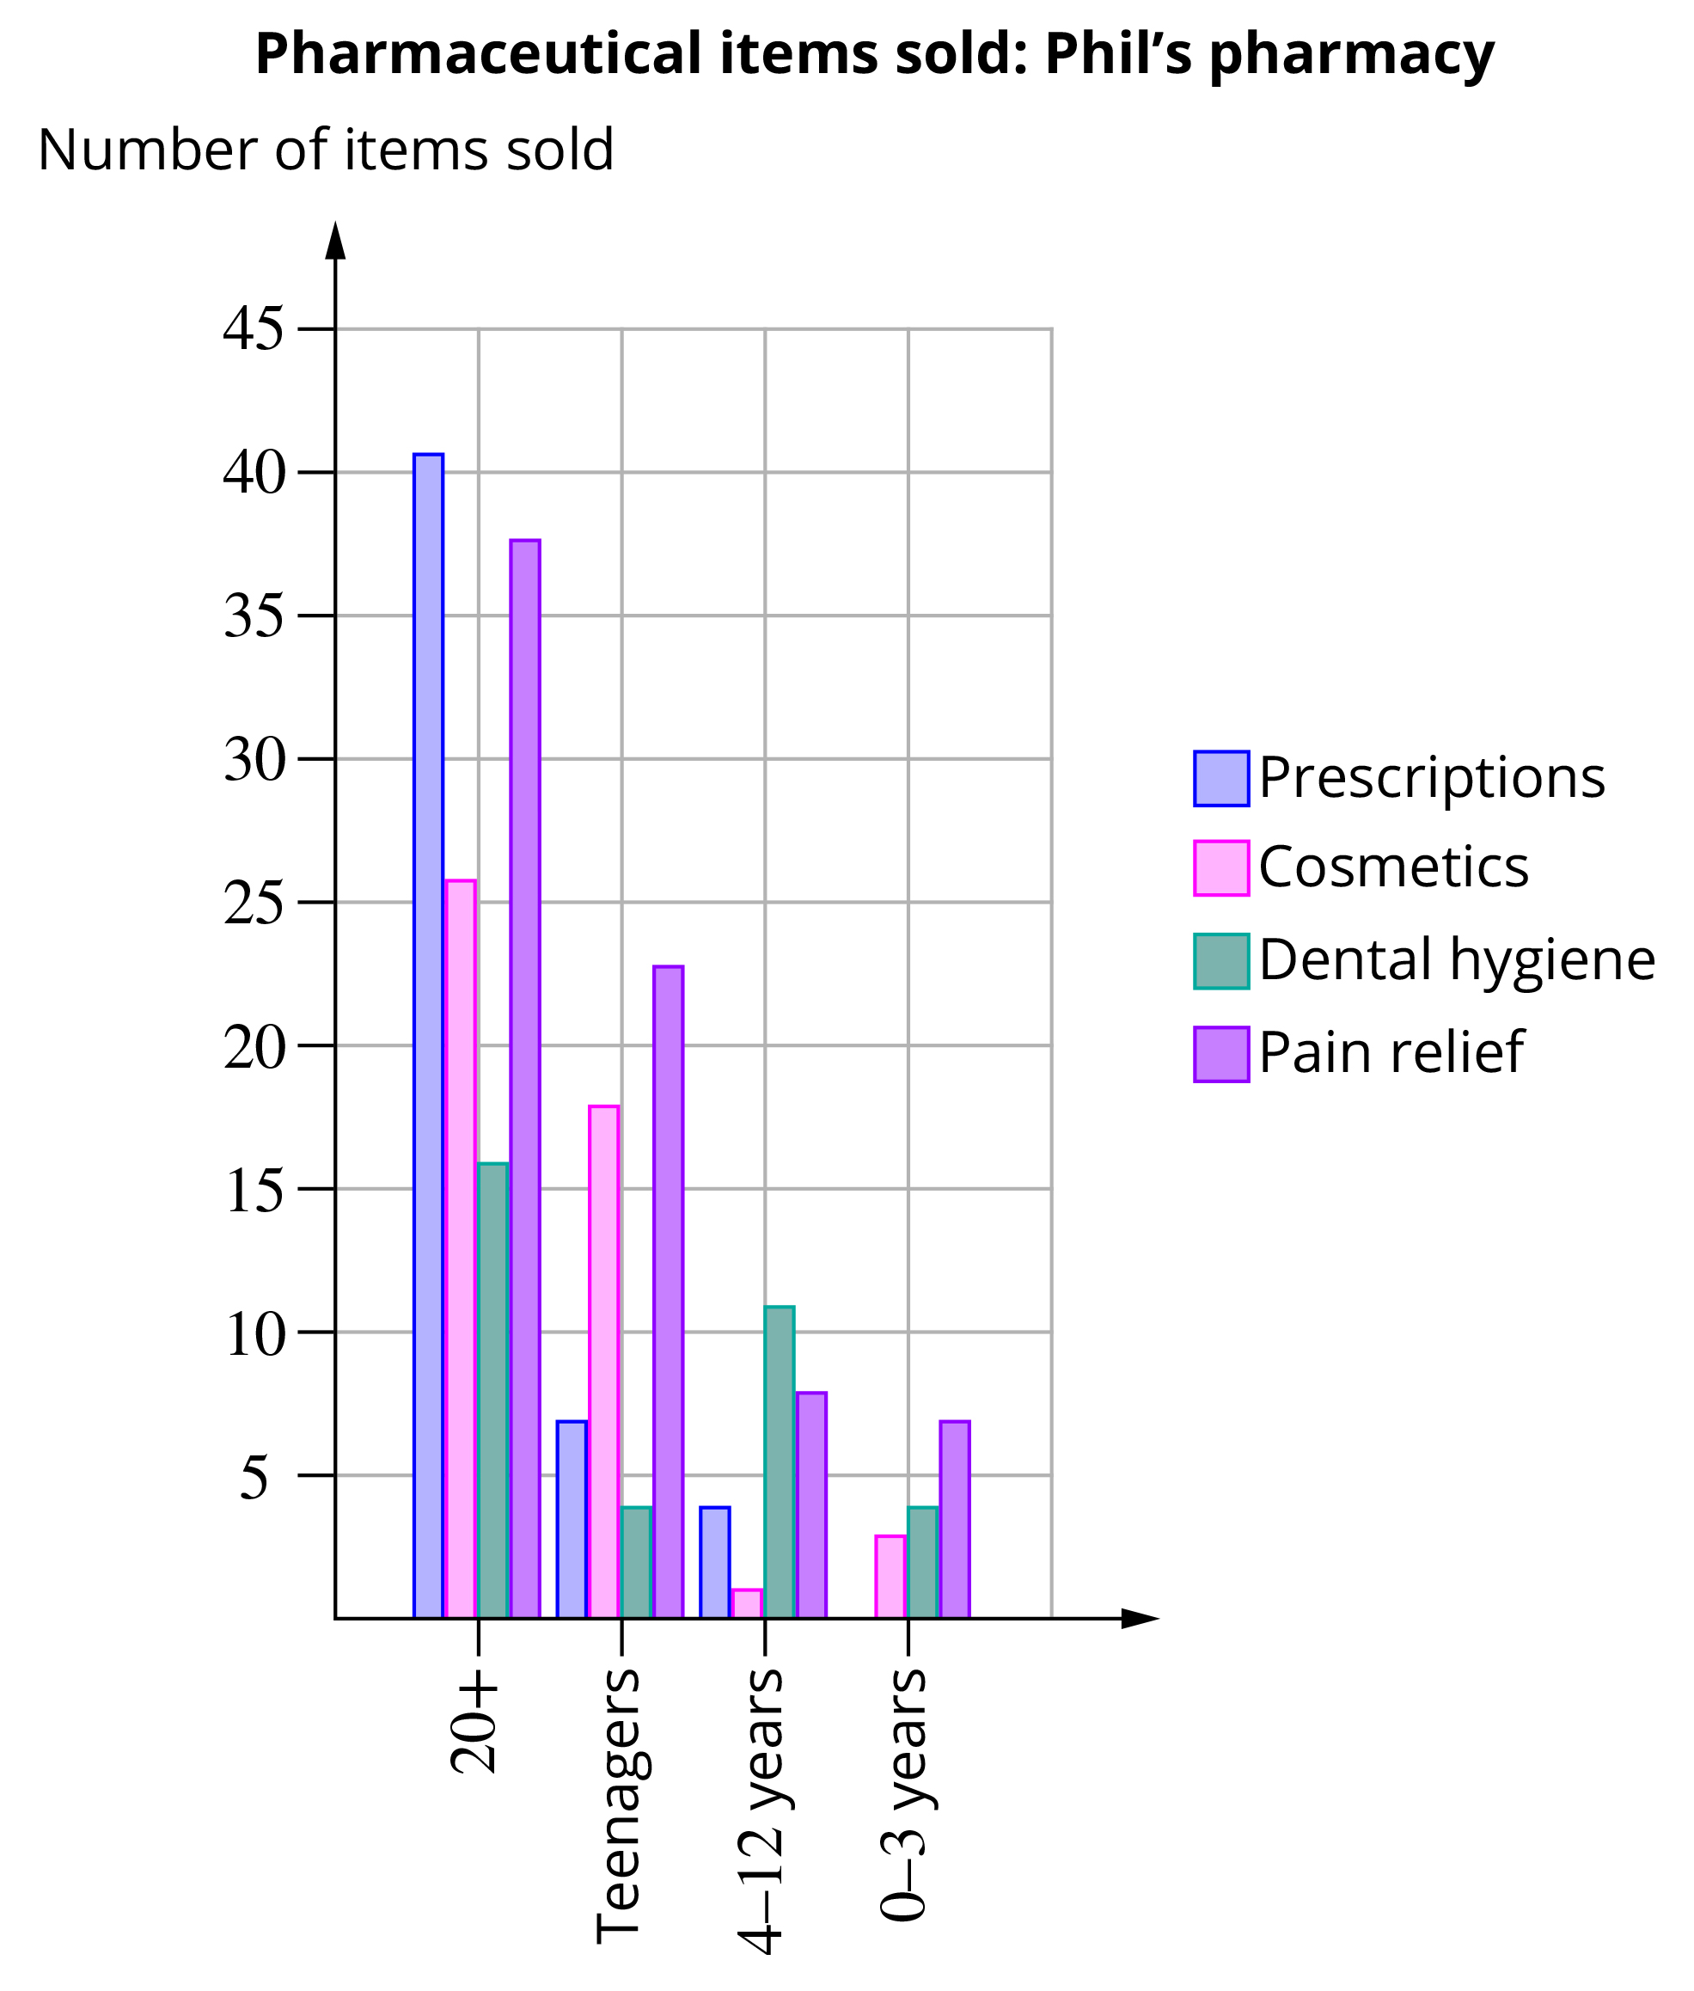

**(a)** Why do you think the ages on the horizontal axis are not grouped evenly? How are they grouped?

**(b)** Find the total number of items purchased by each age group.

**(c)** List the order of popularity of the item types sold at Phil’s Pharmacy over the given period.

**(d)** Does the low purchasing of dental hygiene products mean that the population around Phil’s Pharmacy has poor dental hygiene?

**(e)** Phil calculates the total revenue from the cosmetic items to be $1733.40. Calculate the average cost of each item.

Short answer results: \_\_\_ / 41

Extended answer section

Question 18 10 marks [2.1]

The frequency table below shows the weights (kg) of players in a cricket club.

|  |  |
| --- | --- |
| Weight (kg) | Frequency |
| 64−<66 | 1 |
| 66−<68 | 6 |
| 68−<70 | 10 |
| 70−<72 | 17 |
| 72−<74 | 11 |
| 74−<76 | 10 |
| 76−<78 | 6 |
| 78−<80 | 5 |

(a) Construct a cumulative frequency curve on the axes provided.

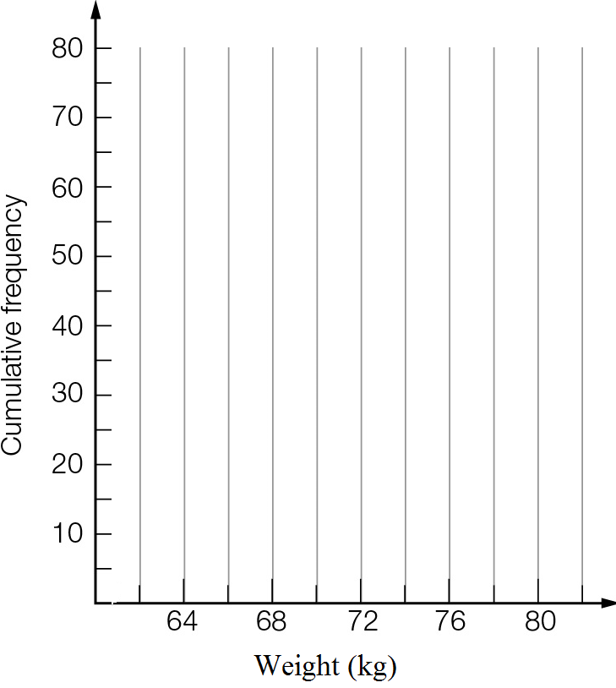

(b) Use the cumulative frequency curve to estimate the lower quartile, median and upper quartile.

(c) Complete the five-number summary and draw a box plot for the data.

|  |  |  |  |  |
| --- | --- | --- | --- | --- |
| Min | *Q*L | Median | *Q*U | Max |
|  |  |  |  |  |

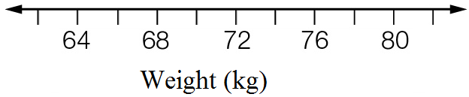

(d) Comment on the accuracy of each of the summary values.

Question 19 10 marks [2.4, 2.6] [10A]

Below are the scores for Maths and English tests.

|  |  |  |  |  |  |  |  |  |
| --- | --- | --- | --- | --- | --- | --- | --- | --- |
| English | 28 | 50 | 25 | 27 | 42 | 38 | 40 | 22 |
| Maths | 48 | 50 | 32 | 36 | 48 | 44 | 42 | 47 |

(a) Considering ‘English mark’ as the independent variable:

(i) Use a calculator to find a relationship between the marks in the form y = mx + b. Round the values of m and b correct to 2 decimal places.

(ii) Sketch the calculator-drawn graph of the data.

(iii) Write the relationship using the variables ‘Maths mark’ and ‘English mark’.

(iv) Use the relationship to estimate the Maths mark for a student who scored 34 for English.

(b) Considering ‘Maths mark’ as the independent variable:

(i) Use a calculator to find a relationship between the marks in the form y = mx + b. Round the values of m and b correct to 2 decimal places.

(ii) Write the relationship using the variables ‘English mark’ and ‘Maths mark’.

(iii) Use the relationship to estimate the English mark for a student who got 38 for Maths.

Question 20 15 marks [2.1, 2.3]

The data below gives the average monthly minimum daily temperatures (in °C) of two Australian cities. The months are in order from January to December.

City X: 12, 12, 11, 9.1, 7.1, 5.1, 4.5, 5.1, 6.4, 7.8, 9.3, 10.8

City Y: 21.2, 20.6, 17.4, 12.5, 8.2, 5.1, 4, 5.9, 9.7, 14.8, 17.9, 20.2

(a) Find the five-number summary of temperatures for each city.

(b) Draw a parallel box plot for the two cities.



(c) Use the median, range and IQR to compare the temperatures for the two cities.

Question 21 7 marks [2.1, 2.3]

The following table lists the number of games won in the winter season of 10 games by the winning sports teams in a school.

|  |  |
| --- | --- |
| Games won | Number of teams |
| 1 | 3 |
| 2 | 3 |
| 3 | 6 |
| 4 | 2 |
| 5 | 4 |
| 6 | 2 |
| 7 | 3 |
| 8 | 0 |
| 9 | 1 |
| 10 | 1 |

(a) What is the mean number of games won by these winning teams?

(b) What proportion of the winning teams won more than half of their games?

(c) The school had 30 teams playing winter sports. Calculate the mean number of wins for all teams.

(d) What proportion of all teams won more than half of their games?

Question 22 18 marks [2.3, 2.8]

The data below gives the weights of newly hatched chicks in grams.

54 63 52 54 74 65 53 57 63 60 53 54 53 54 70 57 66 60 56 64

61 57 65 54 58 65 73 67 65 72 67 52 55 52 73 71 53 67 63 55

(a) Draw a histogram of the weights. Use a class interval of 5, with the first interval being 50-<55.

(b) Construct a box plot for the weights.

(c) Draw a dot plot of the weights.

(d) What do the displays in (a) to (c) tell you about the weights of the chicks?

[10A] (e) Find the mean and standard deviation of the weights.

[10A] (f) Treating the 40 data as the population, use the random numbers below to create six samples of size five from the data.

24 29 20 16 17 22 8 5 33 28

20 19 6 3 8 15 24 7 6 28

16 28 34 17 3 39 24 12 27 28

[10A] (g) Find the sample means and standard deviations.

[10A] (h) Use dot plots to display the distribution of sample statistics about the population statistics.

Extended answer results: \_\_\_ / 60

TOTAL test results: \_\_\_ / 110